[--->Step 1: I navigate to page "Companies"[PASSED]<---]

[--->Step 2: I should see text "Search Companies"[PASSED]<---]

[--->Step 3: I click on companies page title "Browse jobs from Twitter"[PASSED]<---]

[--->Step 4: I should be on page "/company/18670/acme-company-no-642447-jobs"[PASSED]<---]

[--->Step 5: I should see text H one tag "Acme Company No 642447"[PASSED]<---]

[--->Step 6: I navigate to page "Companies"[PASSED]<---]

[--->Step 7: I should see text "Popular Companies"[PASSED]<---]

[--->Step 8: I click on companies "Acme Company No 576874"[PASSED]<---]

[--->Step 9: I should be on page "/company/14732/acme-company-no-576874-jobs"[FAILED]<---]
  
[--->Failed Reason:
org.openqa.selenium.TimeoutException: Expected condition failed: waiting for url to contain "/company/14732/acme-company-no-576874-jobs". Current url: "https://www-master.ci.resume-library.com/companies" (tried for 50 second(s) with 500 milliseconds interval)
Build info: version: '4.6.0', revision: '79f1c02ae20'
System info: os.name: 'Mac OS X', os.arch: 'aarch64', os.version: '13.0.1', java.version: '19'
Driver info: org.openqa.selenium.remote.RemoteWebDriver$ByteBuddy$aW5whcSt
Capabilities {acceptInsecureCerts: false, browserName: chrome, browserVersion: 100.0.4896.127, chrome: {chromedriverVersion: 100.0.4896.60 (6a5d10861ce8..., userDataDir: C:\Users\ltuser\AppData\Loc...}, goog:chromeOptions: {debuggerAddress: localhost:60173}, goog:loggingPrefs: {browser: ALL}, networkConnectionEnabled: false, pageLoadStrategy: normal, performance: false, platformName: WINDOWS, proxy: Proxy(), se:cdpVersion: 100.0.4896.127, setWindowRect: true, strictFileInteractability: false, timeouts: {implicit: 0, pageLoad: 300000, script: 30000}, unhandledPromptBehavior: dismiss and notify, video: true, webauthn:extension:credBlob: true, webauthn:extension:largeBlob: true, webauthn:virtualAuthenticators: true}
Session ID: 589a66a66fa32bcdc7fd498dd45845af
at org.openqa.selenium.support.ui.WebDriverWait.timeoutException(WebDriverWait.java:87)
at org.openqa.selenium.support.ui.FluentWait.until(FluentWait.java:231)
at com.resumelibrary.utilities.Utility.webDriverWaitContainsUrl(Utility.java:147)
at com.resumelibrary.cucumber.stepdefinitions.web.candidate.Others.iShouldBeOnPage(Others.java:135)
at ✽.I should be on page "/company/14732/acme-company-no-576874-jobs"(file:///Users/shubhamr/Desktop/rl-selenium-web/./src/test/java/resources/featurefiles/web/candidate/companies/CompaniesPage.feature:45)
<---]  
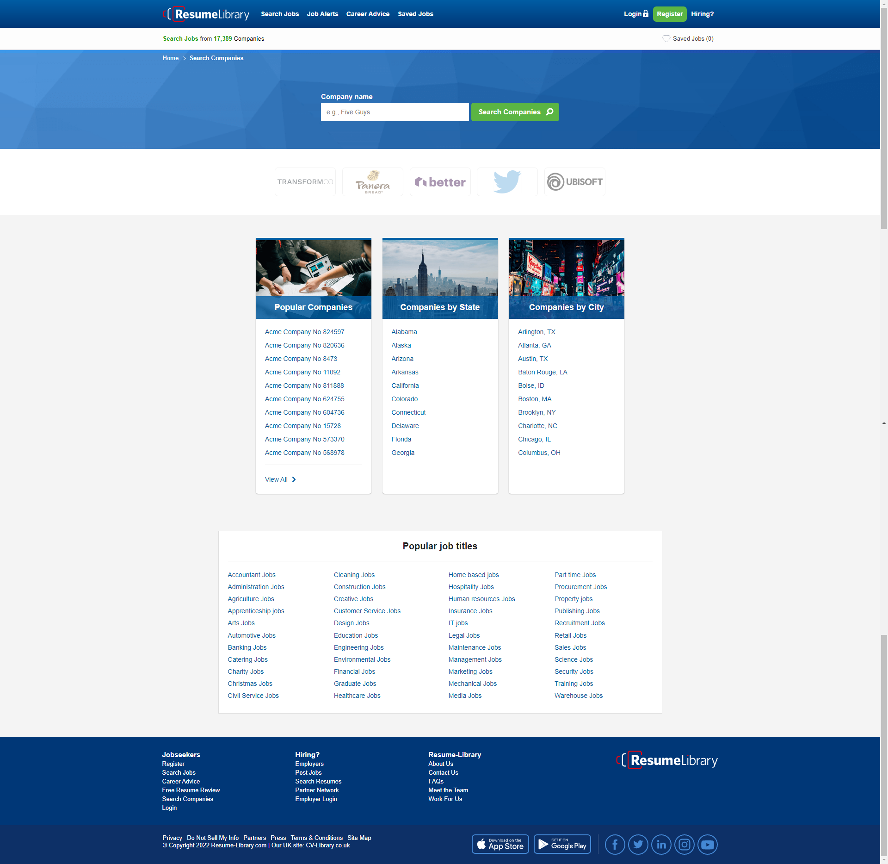

[--->Step 10: I should see text H one tag "Acme Company No 576874"[SKIPPED]<---]

[--->Step 11: I navigate to page "Companies"[SKIPPED]<---]

[--->Step 12: I click on View All[SKIPPED]<---]

[--->Step 13: I should be on page "Companies Browse"[SKIPPED]<---]

[--->Step 14: I should see text "Browse Companies"[SKIPPED]<---]

[--->Step 15: I navigate to page "Companies"[SKIPPED]<---]

[--->Step 16: I should see text "Companies by State"[SKIPPED]<---]

[--->Step 17: I click on companies "Alabama"[SKIPPED]<---]

[--->Step 18: I should be on page "/companies/in-alabama"[SKIPPED]<---]

[--->Step 19: I should see text "Companies in Alabama"[SKIPPED]<---]

[--->Step 20: I navigate to page "Companies"[SKIPPED]<---]

[--->Step 21: I should see text "Companies by City"[SKIPPED]<---]

[--->Step 22: I click on companies "Arlington, TX"[SKIPPED]<---]

[--->Step 23: I should be on page "/companies/in-arlington-tx"[SKIPPED]<---]

[--->Step 24: I should see text "Companies in Arlington, TX"[SKIPPED]<---]

[--->Step 25: I navigate to page "Companies"[SKIPPED]<---]

[--->Step 26: I should see text "Popular job titles"[SKIPPED]<---]

[--->Step 27: I click on popular job title "Accountant Jobs"[SKIPPED]<---]

[--->Step 28: I should be on page "/jobs/accounting"[SKIPPED]<---]

[--->Step 29: I should see text H one tag "Accounting jobs"[SKIPPED]<---]